EXP No. : 3
Date:12/07/26
DML Commands – INSERT, SELECT
AIM:
To perform Data Manipulation Language (DML) commands such as INSERT and SELECT on the Saveetha Hospital database tables.
Procedure:
PROCEDURE:
Step 1: Select the database containing the HOSPITAL table.
Step 2: Insert movie details into the HOSPITAL table using the INSERT statement.
Step 3: Verify that the records have been inserted successfully.
Step 4: Retrieve all the records from the HOSPITAL table using the SELECT statement.
Step 5: Verify the displayed records.
Description
Data Manipulation Language (DML) statements are used for managing data within schema objects.
DML Commands
- INSERT – Inserts data into a table.
- SELECT – Retrieves data from a table.

SQL Queries
Table 1: Patient
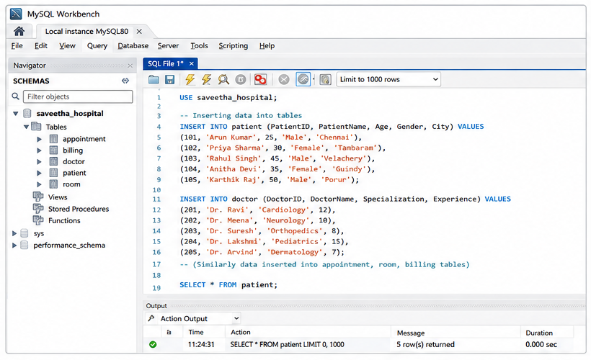
INSERT INTO Patient (PatientID, PatientName, Age, Gender, City)
VALUES
(101, 'Arun Kumar', 25, 'Male', 'Chennai'),
(102, 'Priya Sharma', 30, 'Female', 'Tambaram'),
(103, 'Rahul Singh', 45, 'Male', 'Velachery'),
(104, 'Anitha Devi', 35, 'Female', 'Guindy'),
(105, 'Karthik Raj', 50, 'Male', 'Porur');
Table 2: Doctor
INSERT INTO Doctor (DoctorID, DoctorName, Specialization, Experience)
VALUES
(201, 'Dr. Ravi', 'Cardiology', 12),
(202, 'Dr. Meena', 'Neurology', 10),
(203, 'Dr. Suresh', 'Orthopedics', 8),
(204, 'Dr. Lakshmi', 'Pediatrics', 15),
(205, 'Dr. Arvind', 'Dermatology', 7);
Table 3: Appointment
INSERT INTO Appointment (AppointmentID, PatientID, DoctorID, AppointmentDate)
VALUES
(301, 101, 201, '2026-08-01'),
(302, 102, 202, '2026-08-02'),
(303, 103, 203, '2026-08-03'),
(304, 104, 204, '2026-08-04'),
(305, 105, 205, '2026-08-05');
Table 4: Room
INSERT INTO Room (RoomID, RoomType, ChargesPerDay)
VALUES
(401, 'General', 1500),
(402, 'Semi-Private', 3000),
(403, 'Private', 5000),
(404, 'ICU', 10000),
(405, 'Deluxe', 8000);
Table 5: Billing
INSERT INTO Billing (BillID, PatientID, TotalAmount, PaymentStatus)
VALUES
(501, 101, 5000, 'Paid'),
(502, 102, 7500, 'Pending'),
(503, 103, 12000, 'Paid'),
(504, 104, 6000, 'Pending'),
(505, 105, 9000, 'Paid');
View All Records
Patient Table
SELECT * FROM Patient;
Output
PatientID | PatientName | Age | Gender | City
101 | Arun Kumar | 25 | Male | Chennai
102 | Priya Sharma | 30 | Female | Tambaram
103 | Rahul Singh | 45 | Male | Velachery
104 | Anitha Devi | 35 | Female | Guindy
105 | Karthik Raj | 50 | Male | Porur
Doctor Table
SELECT * FROM Doctor;
Output
DoctorID | DoctorName | Specialization | Experience
201 | Dr. Ravi | Cardiology | 12
202 | Dr. Meena | Neurology | 10
203 | Dr. Suresh | Orthopedics | 8
204 | Dr. Lakshmi | Pediatrics | 15
205 | Dr. Arvind | Dermatology | 7
Appointment Table
SELECT * FROM Appointment;
Output
AppointmentID | PatientID | DoctorID | AppointmentDate
301 | 101 | 201 | 2026-08-01
302 | 102 | 202 | 2026-08-02
303 | 103 | 203 | 2026-08-03
304 | 104 | 204 | 2026-08-04
305 | 105 | 205 | 2026-08-05
Room Table
SELECT * FROM Room;
Output
RoomID | RoomType | ChargesPerDay
401 | General | 1500
402 | Semi-Private | 3000
403 | Private | 5000
404 | ICU | 10000
405 | Deluxe | 8000
Billing Table
SELECT * FROM Billing;
Output
BillID | PatientID | TotalAmount | PaymentStatus
501 | 101 | 5000 | Paid
502 | 102 | 7500 | Pending
503 | 103 | 12000 | Paid
504 | 104 | 6000 | Pending
505 | 105 | 9000 | Paid
Result
Thus, the DML commands INSERT and SELECT were successfully executed on the Saveetha Hospital database, and all records from the five tables were inserted and retrieved successfully.

